**Assignment 01**

**Problem 1**

Problem 1

Loading the file and assigning the Muscle Mass as Y and Age as X

Data=read.csv('A1_Q1_Data.csv',header=FALSE); Y = Data[1]$V1

X = Data[2]$V2

Calculating SXX, SYY and SXY for Deriving values for Beta0 and Beta1 Estimators

SXX = sum( X * X) - length(X) * (mean(X))ˆ2

SXY = sum(X *Y ) - length(X) * mean(X) * mean(Y) SYY = sum( Y * Y) - length(Y) * (mean(Y))ˆ2

Calculating Beta1 and Beta0

BETA1HAT = SXY / SXX

BETA0HAT = mean(Y) - BETA1HAT * mean(X)

1.a.

The Derived Linear Model is Y = 156.34 - 1.18X Plotting the Muscle Mass vs Age

The plot Supports Muscle Mass Decreases with Age Linearly

*# Y = BETA0HAT + BETA1HAT * X # Y = 156.34 - 1.18X*

plot(X,Y,xlab="Age",ylab="Muscle Mass") abline(BETA0HAT,BETA1HAT,col=2,lwd=2)

90

110

# 40 50 60 70



Muscle Mass

50

60

70

80

Age

1.b.

1. Calculating a point estimate difference of Women whose age is deferred by one Year which in turn resulted to be BETA1HAT

Y1= BETA0HAT + BETA1HAT * 50 Y2= BETA0HAT + BETA1HAT * 51

Y2-Y1

## [1] -1.189996

1. Point estimate of Women whose age is 60 Yrs

Y3= BETA0HAT + BETA1HAT * 60 Y3

## [1] 84.94683

1. Value of Residue at 8 Case or Data Point

## RSS_8=(Y[8]-(BETA0HAT + BETA1HAT * X[8]))ˆ2

1. A Point Estimate of Variance

RSS = SYY - BETA1HAT * SXY SIGMASQUARE=RSS/(length(X)-2) SIGMASQUARE

## [1] 66.80082

**Problem 2**

Problem 2

Loading the file and assigning the Crime Rate as Y and Education Percentage in Counties as X

Data=read.csv('A1_Q2_Data.csv',header=FALSE); Y = Data[1]$V1

X = Data[2]$V2

Calculating SXX, SYY and SXY for Deriving values for Beta0 and Beta1 Estimators

SXX = sum( X * X) - length(X) * (mean(X))ˆ2

SXY = sum(X *Y ) - length(X) * mean(X) * mean(Y) SYY = sum( Y * Y) - length(Y) * (mean(Y))ˆ2

Calculating Beta1 and Beta0

BETA1HAT = SXY / SXX

BETA0HAT = mean(Y) - BETA1HAT * mean(X)

1.a.

The Derived Linear Model is # Y = 20517.59 - 170.57X Plotting the Crime Rate vs Education Percentage in County

The plot Supports Crime Rate Decreases with Education Percentage Linearly

*# Y = BETA0HAT + BETA1HAT * X # Y = 156.34 - 1.18X*

plot(X,Y,xlab="Education Percentage",ylab="Crime Rate") abline(BETA0HAT,BETA1HAT,col=2,lwd=2)

10000

14000

# 60 65 70 75 80 85 90



Crime Rate

2000

6000

Education Percentage

1.b.

1. Calculating a point estimate difference whose percentage Education is deferred by one percentage point which in turn resulted to be BETA1HAT

Y_81= BETA0HAT + BETA1HAT * 81 Y_82= BETA0HAT + BETA1HAT * 82

Y_82-Y_81

## [1] -170.5752

1. Point estimate of Women whose graduation percentage is 80

Y_80= BETA0HAT + BETA1HAT * 80 Y_80

## [1] 6871.585

1. Value of Error at 10th Data Point

## E10=Y[10]-(BETA0HAT + BETA1HAT * X[10])

1. A Point Estimate of Variance

RSS = SYY - BETA1HAT * SXY SIGMASQUARE=RSS/(length(X)-2) SIGMASQUARE

## [1] 5552112

**Problem 3**

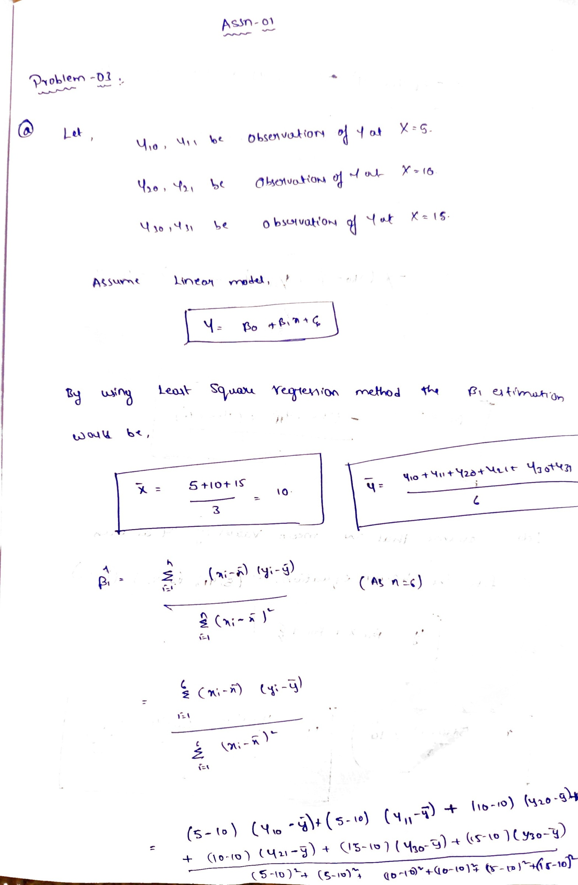

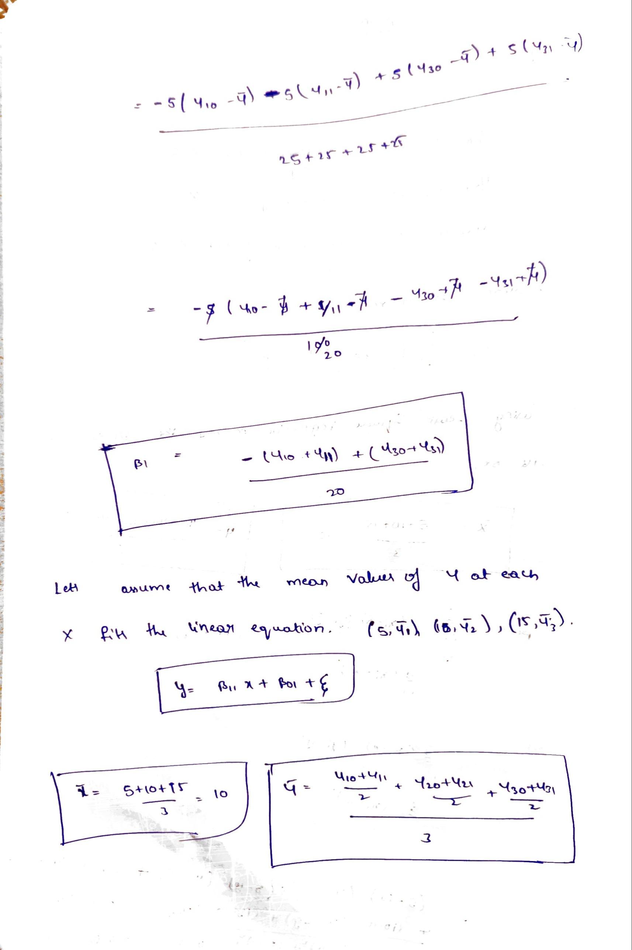

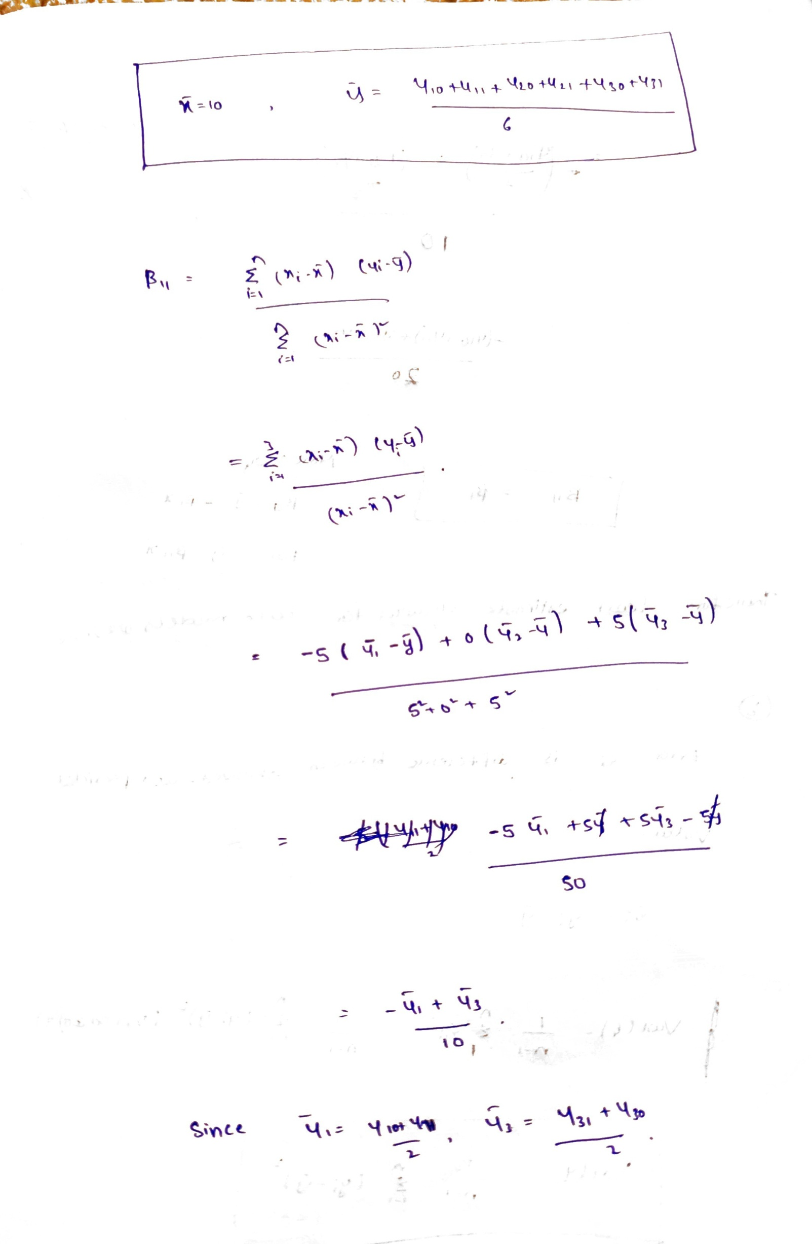

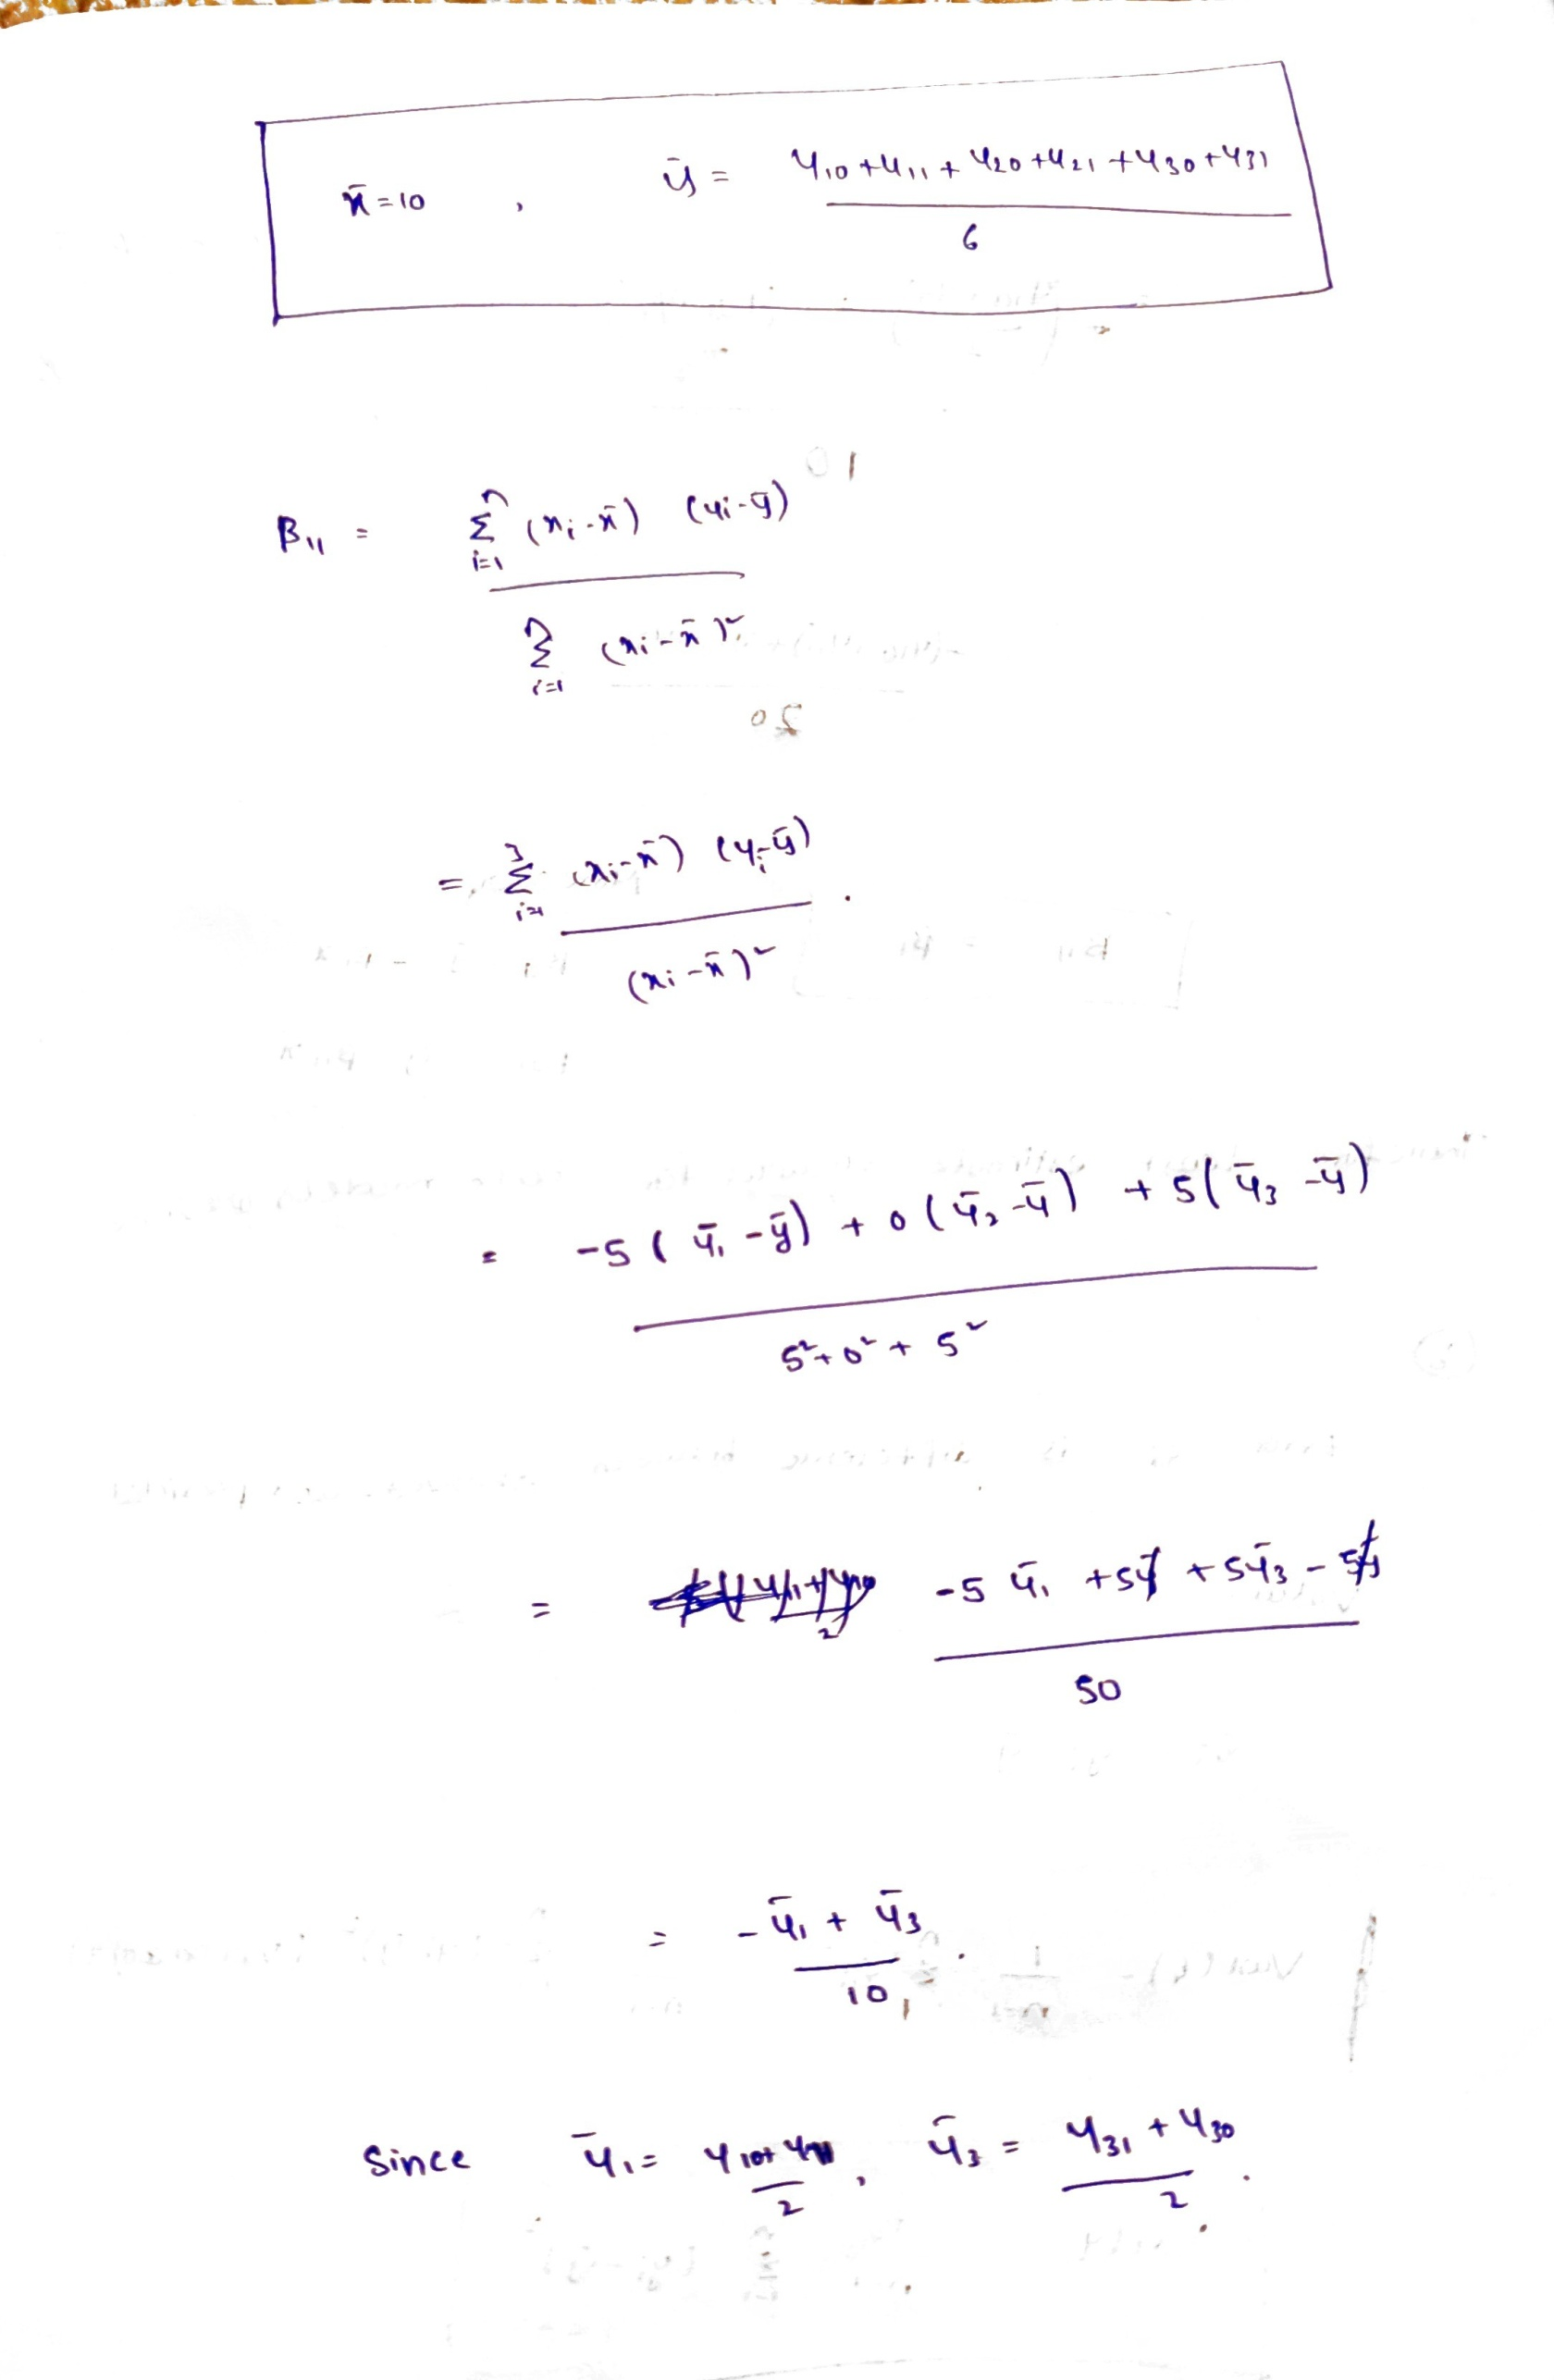

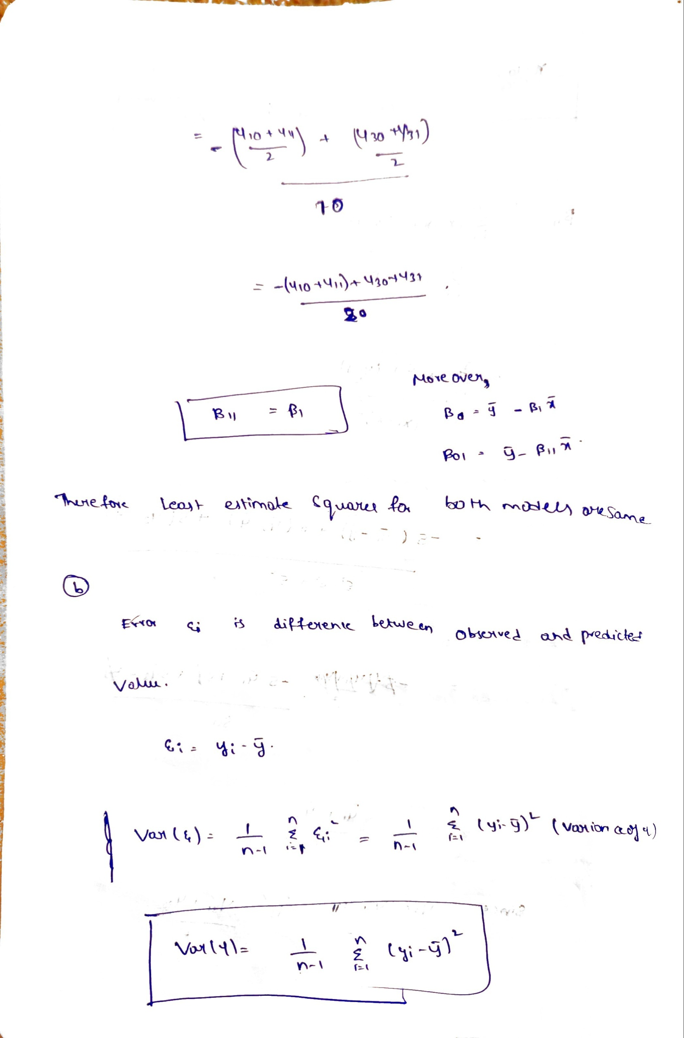

**Problem 4**

a.

We know that MAximum Likelyhood Function is



Figure 1: Maximum Likely Hood

LH=(1/(2*pi*SIGMASQUARE)0.5)6 * exp((-1/(2*16))*sum((Y-BETA1HAT*X)ˆ2))

Loading the file and assigning the Typographical Errors as Y and Number of Manuscripts as X Adding Length and Sigma Squared Value

Data=read.csv('A1_Q4_Data.csv',header=FALSE); Y=Data[1]$V1

X=Data[2]$V2 N=length(X) SIGMASQUARE=16

1. Evaluating Likelyhoods for B1=17,18,19 For B1=18 Likelyhood function is largest

B11=17

L1=(1/(2*pi*SIGMASQUARE)ˆ0.5)ˆ6*exp((-1/(2*16))*sum((Y-B11*X)ˆ2)) B12=18

L2=(1/(2*pi*SIGMASQUARE)ˆ0.5)ˆ6*exp((-1/(2*16))*sum((Y-B12*X)ˆ2))

B13=19

L3=(1/(2*pi*SIGMASQUARE)ˆ0.5)ˆ6*exp((-1/(2*16))*sum((Y-B13*X)ˆ2))

c.Calculating MLH for Beta1 from formula.

The Value of Beta1 is 17.85 from the formula which is approximately equal to 18.

SXX=sum( X*X)-length(X)*(mean(X))ˆ2 SXY=sum(X*Y )-length(X)*mean(X)*mean(Y)

BETA1HAT=SXY/SXX BETA1HAT

## [1] 17.85237

MLH for BETA1HAT

L4=(1/(2*pi*SIGMASQUARE)ˆ0.5)ˆ6*exp((-1/(2*16))*sum((Y-BETA1HAT*X)ˆ2))

L4

## [1] 2.542286e-07

1. Plotting the MLE for range of Beta1s between 17 and 19

Yo=seq(17,19,by =0.001)

Yabs=c()

**for** (i **in** Yo)

{

BETA1HATO=i

Yabs=append(Yabs,(1/(2*pi*SIGMASQUARE)ˆ0.5)ˆ6*exp((-1/(2*16))*sum((Y-BETA1HATO*X)ˆ2)))

}

plot(Yo,Yabs,xlab="Beta1",ylab="Max Likelyhood Function")

2e−07

3e−07

# 17.0 17.5 18.0 18.5 19.0

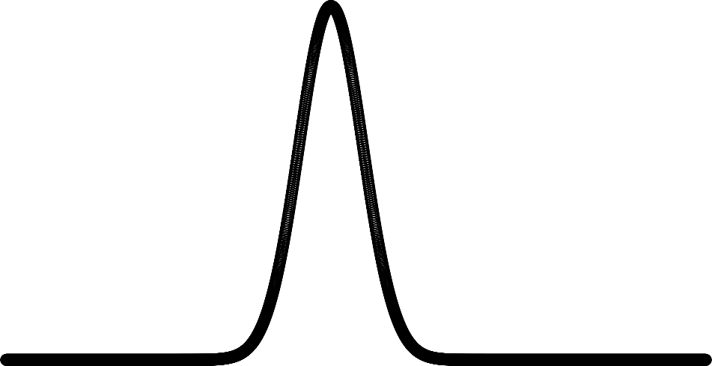

Max Likelyhood Function

0e+00

1e−07

Beta1

Pointing the maximum value estimator from the plot. This Value 17.92 corresponds to result of c which is 17.85

Yo[which(Yabs==max(Yabs))]

## [1] 17.928

**Problem 5**

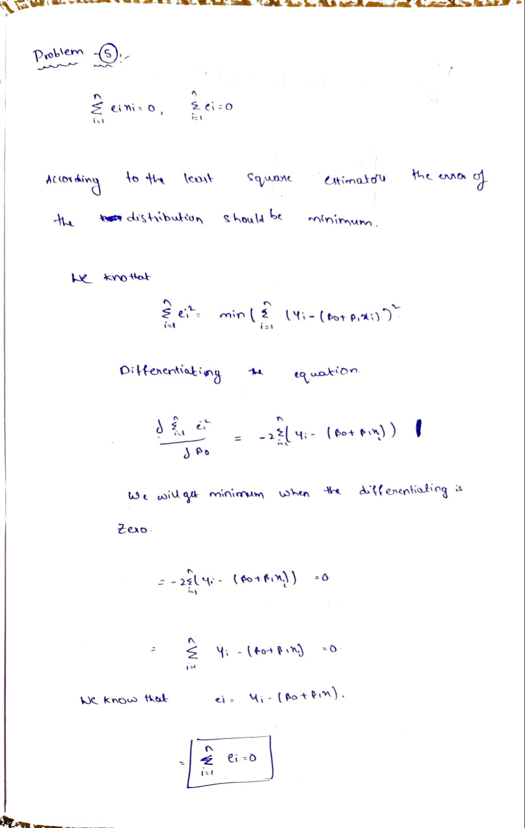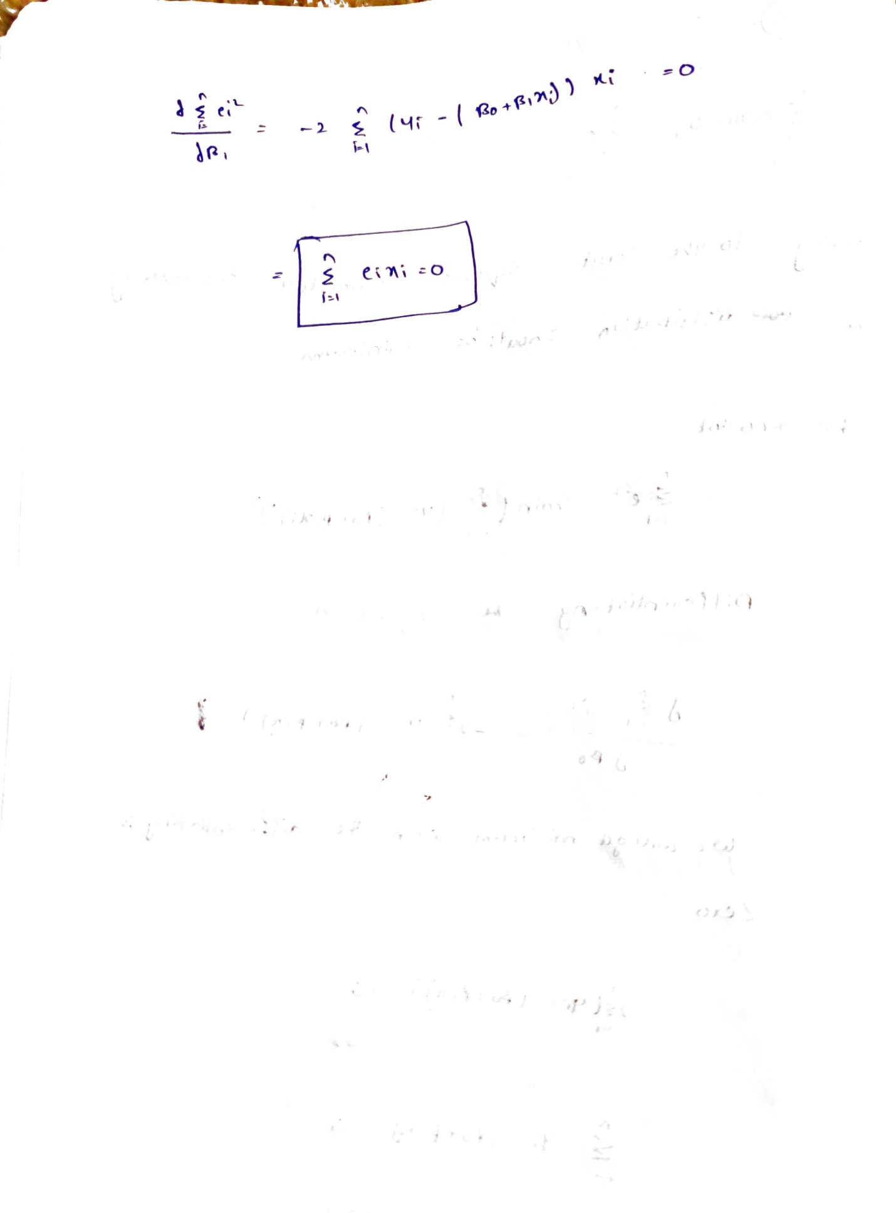

**Problem 6**

